**IVR Update: SDCB EORs/Employees for SDCB PCS and Respite Services:**

There was a national outage on the AuthentiCare IVR yesterday but the issue is now resolved. Only SDCB EORs/**employees** who use IVR for SDCB PCS and Respite services were impacted.

Please note that:

* EORs and employees who use the AuthentiCare mobile app were not impacted. No actions are needed.
* EORs and employees who have an electronic timesheet exception were not impacted. No actions are needed.
* EORs and employees who are not yet set up in AuthentiCare were not impacted. Continue to use *FOCoSOnline* for time entry.

**If EORs use the AuthentiCare system and their employees use IVR, EORs should take the following steps to manually enter a claim for the SDCB PCS and Respite services that were provided yesterday, 3/9/21.** If you need assistance in completing this task, please reach out to your Support Broker.

Step 1:  log into AuthentiCare and Add new claim - Standard:

Please select the appropriate SDCB procedure code for PCS or respite.

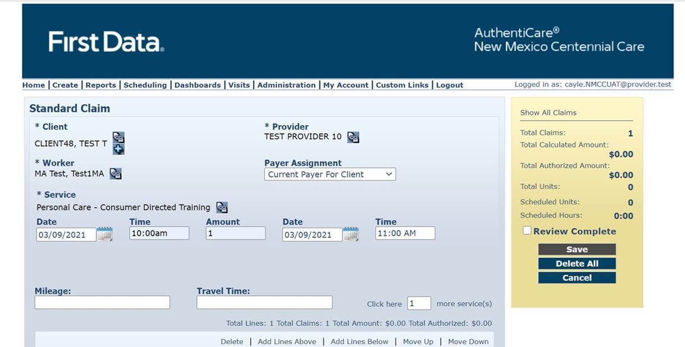

Step 2 enter the worker, client, and service into the appropriate boxes.  Once worker, client, and service are entered time entry boxes will appear that should be populated with the time of the visit.  When complete hit save.

