**DDW and Supports Waiver Agency Providers:**

***On March 9, 2021*** there was a national outage on the AuthentiCare IVR but the issue is now resolved.  In Palco NM there are only two options to track time and they are IVR claims or manual web entries.  Since the IVR was down yesterday***,*** agency provider administrators will need to manually enter worker/employee clock in and clock out information on the website.  Please follow the 3 step processbelow:

Step 1:  Log into AuthentiCare and Add new claim - Standard:

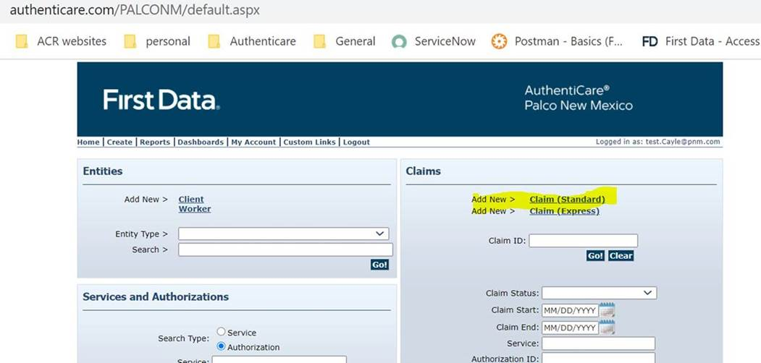

Step 2: Enter the worker, client, and service into the appropriate boxes.  Once worker, client, and service are entered time entry boxes will appear that should be populated with the time of the visit.  When complete hit save.

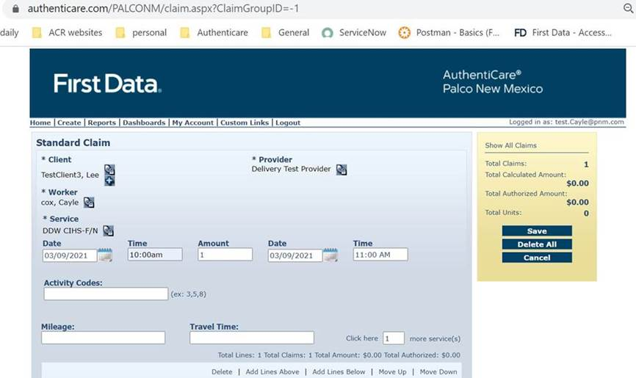

Step 3:  Ensure you see “successfully saved claimID message.  Here is the completed screen

